# Meeting started at 8:36pm and ended at 10:10pm.

# People present in the 3rd meeting on Lab week 4:

Souheil Al-Awar Present

David Boivin Present

Benson Chan **Absent**

Annes Cherid Present

Carl Neil Cortes-Nazareth Present

Gaoshuo Cui Present

**Yassine Laaroussi Dropped**

Robert LaviolettePresent

Karim Loulou Present

Ke MaPresent

Kevin McAllister Present

Yogesh Nimbhorkar **Absent**

# Meeting points:

* TA came to us for a pre-demo, here are the summary points:
  + Documenters
    - There is a good amount of information written already, 7 pages containing the purpose, the context, the business goals, some of the domain concepts, some of the use case 1;
    - Domain model (shows a basic ideology of the game), use cases and MVC architecture not ready yet;
    - Need to write a brief description on every diagram.
    - Implement design pattern;
    - Need a table of content, make sure everything is organized;
  + Coders:
    - Most of the code is ready;
    - Karim made a database for us to use;
    - Still working on the strategy, but the implementation is basically finished;
    - TA need only basic functional UI;
    - Unit test: run some basic tests, need to setup specific events, basic tests (nothing too complicated like Spymaster actions, command strategy); it is basically what we expect from these events and what it gives us.
    - Controller will make the model reveal the card;
    - We are using observers/observables so that whenever the card is modified the observer will be like <<this card is modified>>, it was swapped, then revealed from hidden status and does its job whatever it needs to do like reduce number of teammates to find or trigger event of end of turn.
    - Kevin explained how the code works with the MVC concept;
    - Make sure specify who did what on coding and documents;
  + Every document should be on LaTex, converted into pdf; A general informative diary and a specific one.
  + Have a compiled java executable file;
* Documenters will have some work done during the weekend
  + Use cases: Carl, Gaoshuo & Benson;
  + Robert: MVC;
  + Souheil: Domain model
  + Business Goals: Makeup stuff, up to us to decide, Goals should be linked with the output it brings and how we are going to achieve them.
  + Constraints: Time of a click-> Timing of events, this is a guideline of how our program should run and act.
  + NEXT MEETING TUESDAY 5th February 2018 @4:00pm;
* Kevin and David talked about how to link messages between GUI and the code.

# Some other things we talked about

1. In our meeting yesterday (Documenter’s 1st meeting on Tuesday 22nd Feb) we looked over both the sample latex document as the example one from iteration 2. Are there any hard guidelines to follow for this document, or is the goal simply to make an ENCS282-style-written business document (technical writing document, or whatever it's called) for the overall project that includes everything in it?
2. Robert: From my understanding, what we need from the documenters for iteration 1 is the shell of a latex document, rather than an entire written-up thing. this would include: the system requirements specification (which is just a sub-section), all of the information about all of the use cases we do (including diagrams, etc), but also the outline of everything else that's going to start going in it and diagrams for the basics (eg. some of what we discussed last night). My question is if that's a correct summary of the documentation we need.
3. Benson is part of our team, all good
4. 9:40pm, Annes took the team together and talked about the Iteration due date and the Demo due date. We have presented our work of the system for iteration 1 to the TA. The team meeting reviewed what needs to be done over the next week to get the application ready for submission; the team should review status of the document, and review the timeline overall for iteration 1, assigned tasks and deadlines, for both the software and the document to be ready for submission. There will be a team meeting for the documenters on Tuesday 5th Feb. @4:00pm.

# Team subgroups:

**For Increment 1:**

**Coders:** Kevin, Karim, David & Yogesh;

**Organiser:** Annes;

**Documenters:** Souheil, Gaoshuo, Ke, Benson, Robert & Carl Neil.

Meeting ended at 10:10 PM

# Annex 1

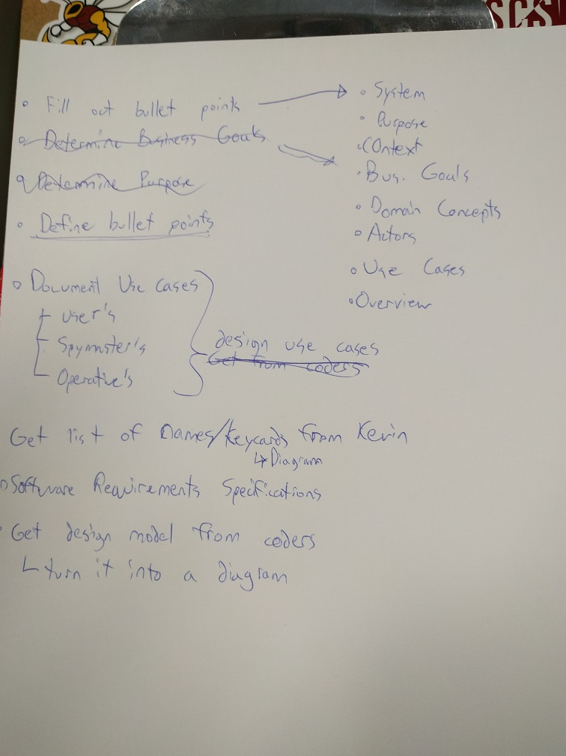

# Annex 2

